Amber Beaton

Leonora Diagnostic Centre

September 2018

Database specifications

Dental Department

**Revision Sheet**

|  |  |  |
| --- | --- | --- |
| **Release No.** | **Date** | **Revision Description** |
| Rev. 0 | 5/30/00 | Database Specifications Template and Checklist |
| Rev. 1 | 4/10/02 | Conversion to WORD 2000 format |
|  |  |  |
|  |  |  |
|  |  |  |
|  |  |  |
|  |  |  |

|  |  |
| --- | --- |
|  | **Database Specifications Authorization Memorandum** |

I have carefully assessed the Database Specifications for the (System Name). This document has been completed in accordance with the requirements of the HUD System Development Methodology.

MANAGEMENT CERTIFICATION - Please check the appropriate statement.

______ The document is accepted.

______ The document is accepted pending the changes noted.

______ The document is not accepted.

We fully accept the changes as needed improvements and authorize initiation of work to proceed. Based on our authority and judgment, the continued operation of this system is authorized.

_______________________________ _____________________

NAME DATE

Project Leader

_______________________________ _____________________

NAME DATE

Operations Division Director

_______________________________ _____________________

NAME DATE

Program Area/Sponsor Representative

_______________________________ _____________________

NAME DATE

Program Area/Sponsor Director

**DATABASE SPECIFICATIONS**

**TABLE OF CONTENTS**

Page #

1.0 GENERAL INFORMATION 1-1

1.1 Purpose 2

1.2 Scope 2

1.3 System Overview 2

1.5 Acronyms and Abbreviations 3

1.6 Points of Contact 3

2.0 DATABASE IDENTIFICATION AND DESCRIPTION 4

2.1 Naming Conventions 4

2.2 Database Identification 4

2.3 Systems Using the Database 4

2.4 Relationship to Other Databases 4

2.5 Schema Information 5

2.5.1 Description 5-6

2.5.2 Physical Design 7

2.5.3 Physical Structure 8

2.6 Special Instructions 8

3.0 DATABASE ADMINISTRATIVE INFORMATION 9

3.1 Responsibility 9

3.2 System Information 9

3.2.1 Security 9

3.3 Storage Requirements

3.4 Recovery 9

3.5 Error Handling 10

Reference 11

1. **General Information and Requirements**
   1. **Purpose**

The purpose of this database specification is to employ a more efficient way to securely and store valid and mandatory information about patients who visit the Leonora Diagnostic Centre.

* 1. **Scope**

This database management system will focus on one section of the hospital, which is the Dental Department.

* 1. **Problem Statement**

Shavannie, the manager of the dental department, from the Leonora Diagnostic Centre, has found it very tedious to record and keep track of her patient’s required information. She is currently using manual books to document information needed such as: The Name, Age, Date of entry and Address. She also has to record the teeth number and the number of anesthetics used on the patient’s teeth. This method was working for the past year, however, as more patients are being assigned to the dental department, the performance rate has dropped significantly. It is becoming more time-consuming for her to access, edit and even record the patients’ information. Also, the information can be easily breached and used by whoever gets their hands on the book.

She would like a system to be implemented so that she can systematically record the patients’ information within a database and also keep the information safe. This database should allow them to access, record and process the given information faster so that it would be less time consuming. Sakuran Hirman, a database manager has been assigned the task to create this database.

* 1. **System Overview**

|  |  |
| --- | --- |
| **System Overview** | **Details** |
| System Name | Leonora Diagnostic Centre Dental Database |
| System Code | BNG-7H921 |
| System Type | Client Sever Application |
| System Category | Major Application |
| Operational Status | Under Development |
| Database Name | LDC-Dental Record |

This MySQL server will be the main interface. The manager of the dental department can access, record and edit the required information about the patients easily and quickly. Only the manager of the dental department, the Hospital Administrator, who have permission to have knowledge of this information and the database manager can access this level of information.

The MySQL is a relation database management system (RDB MS) that would be used to link attributes that are related to each other.

* 1. **Abbreviations**

|  |  |
| --- | --- |
| **Abbreviation** | **Meaning** |
| LDC | Leonora Diagnostic Centre |
| RDBMS | Relation Database Management System |

**1.6Points of Contact**

|  |  |  |  |
| --- | --- | --- | --- |
| **Position/Role** | **Name** | **Email Address** | **Contact Number** |
| Client | Shavannie Persaud | Ldc_dental@gmail.com | +592 629-8143 |
| Database Manager | Sakuran Hirman | S_hirman@gmail.com | +592 672-5194 |

1. **DATABASE IDENTIFICATION AND DESCRIPTION**
   1. **Naming Convention**

* User names: User names should begin with “mysql” (for example, mysqluser1, mysqluser2)
* Database names: Unless you have a special reason not to, use the default database named test that is already created for you. For tests that need to operate outside the test database, database names should contain “test” or begin with “mysql” (for example, mysqltest1, mysqltest2)
* Table names: t1, t2, t3, ...
* View names: v1, v2, v3, ...
  1. **Database Identifications**

The name of the database will be called : **LDC-Dental Record.**

The system code of the database will be called : **BNG-7H921.**

**2.3 System Using the Database**

The system that will be using the database is the MySQL sever.

The version is Standard Edition 2012.

|  |  |  |  |
| --- | --- | --- | --- |
| **Vendor** | **Product** | **Version** | **Comments** |
| Microsoft | Microsoft SQL server | Standard Edition 2012 | Database Management System |

**2.4 Relationships to other Database**

This database will have a one to many relationship. After the attributes are Entities are defined, the attributes of those entities will be identified. Then entities are: Patient and Teeth. The attributes for Patients are: Name, age, address, date of entry and the attributes for Teeth are: Teeth-number and the number of anesthetics that will be used on the teeth. The relationship between the two entities (Patient and Teeth) is :* **Patient removes Teeth**.

**2.5 Schema Information**

**Description:** The Database can be defined at three stages. Namely: The External Schema, the conceptual/ logical schema and finally the physical schema.

For the external schema, the user of the database may see titles such as: Patient No., FName, LName, Age, Date of entry, Address, Teeth Number, Number of Anesthetics. For the conceptual/ logical schema.

|  |  |  |  |  |  |
| --- | --- | --- | --- | --- | --- |
| **Patient No.** | **FName** | **LName** | **Age** | **Date of Entry** | **Address** |
| 1 | John | Harris | 27 | 2018-09-11 | 12 Leonora WCD |
| 2 | Aiden | Anderson | 18 | 2018-09-11 | 11 Den Amstel WCD |
| 3 | April | Smith | 20 | 2018-09-11 | 7 Uitvlugt WCD |

For the conceptual/ logical schema, it store data in terms of the data model of the Database Management system (DBMS). It describes all information that is stored in the database.

|  |  |
| --- | --- |
| **Title** | **Data Type** |
| Patient Number | Integer |
| FName | String |
| LName | String |
| Age | Integer |
| Date of Entry | Date |
| Address | Lot-Integer, Address-String |
| Teeth Number | Integer |
| Number of Anesthetic | Integer |

For the physical schema, the description on the storage details can be found. This is how the information within the database is stored.

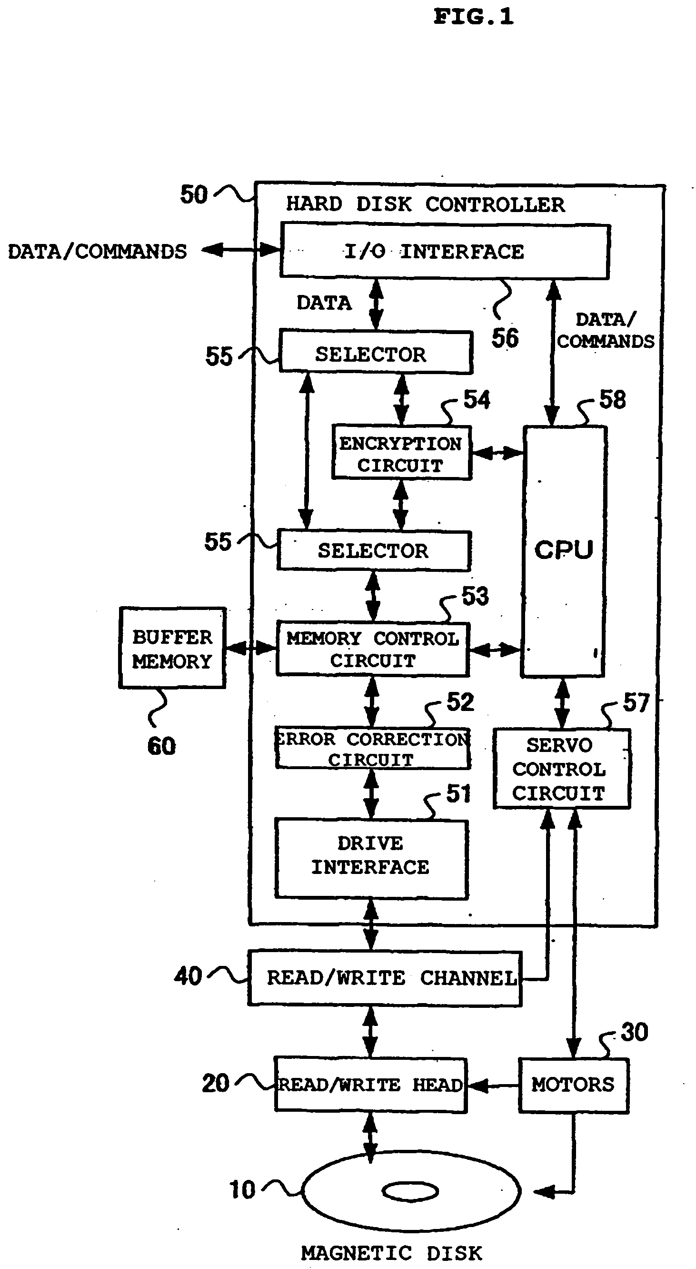

**2.5.2 Physical Design**

Below is an ER- database design of how this database will look like:

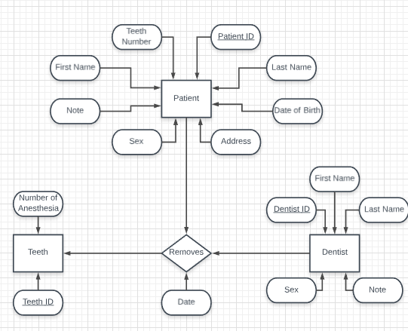

**2.5.3 Physical Structure**

**Patient**

|  |  |  |  |  |  |
| --- | --- | --- | --- | --- | --- |
| **Patient No.** | **FName** | **LName** | **Age** | **Date of Entry** | **Address** |
| 01 | John | Harris | 27 | 2018-09-11 | 12 Leonora WCD |
| 02 | Aiden | Anderson | 18 | 2018-09-11 | 11 Den Amstel WCD |
| 03 | April | Smith | 20 | 2018-09-11 | 7 Uitvlugt WCD |

**Teeth**

|  |  |  |
| --- | --- | --- |
| **Teeth Number** | **Number of Anesthetic** | **Number of Teeth** |
| 1_3 | 1 | 1 |
| 2_4 | 2 | 1 |
| 3_3 | 1 | 1 |

**2.6 Special Instruction**

The only persons who should have entry to the database are:

* The Dental Manager
* The Hospital Administrator
* The Database Manager

A code will be sent to the emails of the dental manager and hospital administrator. They should be able to utilize that code to log in as an admin. The dental manager as an admin should be able to access, edit and update the information of the patients within the database, while the hospital administrator should only be able to access and update the information within the database. The database manager should be able to update, secure and manage the database. The database manager will provide the instructions on how to use the database.

1. **DATABASE ADMINISTRATIVE INFORMATION**
   1. **Responsibility**

|  |  |
| --- | --- |
| **Personnel** | **Responsibility** |
| Database Manager – Sakuran Hirman | Database Administrator |
| Database Manager – Sakuran Hirman | System Administrator |
| Database Manager – Sakuran Hirman | Security Administrator |

Sakuran Hirman, the database manager is responsible for the upkeep of the database. The role may include capacity planning, installation, configuration, database design, migration, performance monitoring, security, troubleshooting, as well as backup and data recovery.

* 1. **System Information**

MySQL

* + 1. **Security**

There are general factors that affect good security. These include choosing good passwords, not granting unnecessary privileges to users, ensuring application security by preventing SQL injections and data corruption.

Security of the installation itself. The data files, log files, and the all the application files of your installation should be protected to ensure that they are not readable or writable by unauthorized parties.

Security of the installation itself. The data files, log files, and the all the application files of your installation should be protected to ensure that they are not readable or writable by unauthorized parties.

3.3 **Storage Requirements**

|  |  |
| --- | --- |
| **Storage Device** | **Minimum Free Space** |
| Hard disk | 16 GB |

**3.4 Recovery**

The information on the database will be saved in Cloud SQL for the MySQL database, the hard dive disk, RAM, etc.

**3.5 Error Handling**

The database manager should be able provide a document that contains information on how to handle possible errors that are within the database.

**REFERENCE**

<http://www.dartmouth.edu/~bknauff/dwebd/2004-02/DB-intro.pdf>

<https://www.techrepublic.com/article/relational-databases-defining-relationships-between-database-tables/>

<https://downloads.mysql.com/docs/mysql-security-excerpt-5.6-en.pdf>

Delight Smiles

Name: USI:

* Amber Beaton………………………...1028554
* Ronaldo Springer………………..……1025047
* Feliciann Elliot………………………..1022055
* Jason Jacobs…………………………..1028494
* Kim Shing Chong…………………….1025719

Introduction

Shavannie, the manager of the dental department, from the Leonora Diagnostic Centre, has found it very tedious to record and keep track of her patient’s required information. She is currently using manual books to document information needed. This method was working for the past year, however, as more patients are being registered to the dental department, the performance rate has dropped significantly. It is becoming more time-consuming for her to access, edit and even record the patients’ information. Also, the information can be easily breached and used by whoever gets their hands on the book.

She would like a database system to be implemented so that she can systematically record and secure the patients’ information within a database and record the dentist that does the operation on the patient’s teeth.

This database should allow them to access, record and process the given information faster so that it would be less time consuming.

Sakuran Hirman, a database manager has been assigned the task to create this database. The database should be able to edit the patient’s information such as: First and Last name, age, address, patient’s sex, number of anesthetics used on the teeth, Teeth ID, Dentist Name, Dentist ID and dentist’s sex.

ENTITY RELATIONSHIP DIAGRAM



CONCEPTUAL DATABASE DESIGN

ENTITY SET

* Patient
* Teeth
* Dentist

ATTRIBUTES OF ENTITIES

Patient

* Patient ID
* Teeth Number
* First Name
* Last Name
* DOB
* Sex
* Address
* Note

Teeth

* Teeth ID
* Number of Anesthesia

Dentist

* Dentist Name
* Dentist ID
* Sex
* Note

ATTRIBUTES OF RELATIONSHIP

Removes

* Date: DATE

RELATIONSHIPS BETWEEN ENTITIES

* [Dentist] <REMOVES> [Teeth]

Example:

Patient Table

|  |  |  |  |  |  |  |
| --- | --- | --- | --- | --- | --- | --- |
| PID (P-K) | Patient Name | First Name | Age | Sex | Address | Note |
| 0000001 | Pat | Harry | 45 | F | 11 Uitvlugt WCD |  |
| 0000002 | John | Smith | 26 | M | 21 Den Amstel WCD |  |
| 0000003 | Sam | Jones | 37 | M | 77 Leonora WCD |  |

Dentist Table

|  |  |  |  |  |
| --- | --- | --- | --- | --- |
| DID (P-K) | First Name | Last Name | Sex | Note |
| 0000021 | Shivnarine | Singh | M |  |
| 0000102 | April | Rose | F |  |
| 0000035 | Alliah | Ali | F |  |

Teeth Table

|  |  |
| --- | --- |
| TID (primary key) | Number of Anesthesia |
| 0000001 | 1 |
| 0000002 | 2 |
| 0000003 | 2 |

Removes Table

|  |  |  |  |
| --- | --- | --- | --- |
| Teeth ID (primary key) (FK) | Dentist ID (FK) | Patients ID (FK) | Date |
| 0000001 | 0000021 | 0000001 | 2018-09-15 |
| 0000002 | 0000102 | 0000002 | 2018-09-17 |
| 0000003 | 0000003 | 0000003 | 2018-09-22 |

LOGICAL DATABASE DESIGN

**Dentist:**

* Dentist ID: INT (7)
* First Name: VARCHAR (15)
* Last Name: VARCHAR (15)
* Sex: CHAR (1)
* Note: VARCHAR (100)

**Removes:**

* Remove ID: INT (7)
* Date: DATE
* Dentist ID: INT (7)
* Teeth ID: INT (7)
* Patient ID: INT (7)

**Teeth:**

* Teeth ID: INT (7)
* Number of Anesthesia: INT (1)

**Patient:**

* Patient ID: INT (7)
* Teeth Number: INT (7)
* First Name: VARCHAR (15)
* Last Name: VARCHAR (15)
* DOB: DATE
* Sex: CHAR (1)
* Address: VARCHAR (120)
* Note: VARCHAR (100)